Login & Register Functionality

**UI Design for Login & Register Functionality: (Primary Actor: VT Student/Staff Member)**

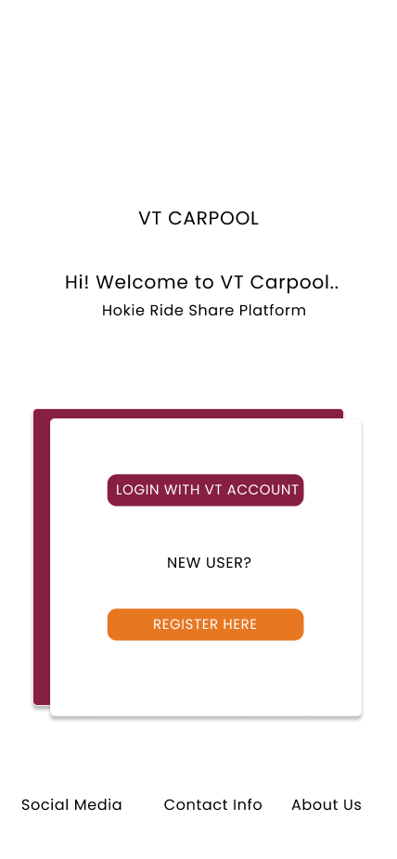

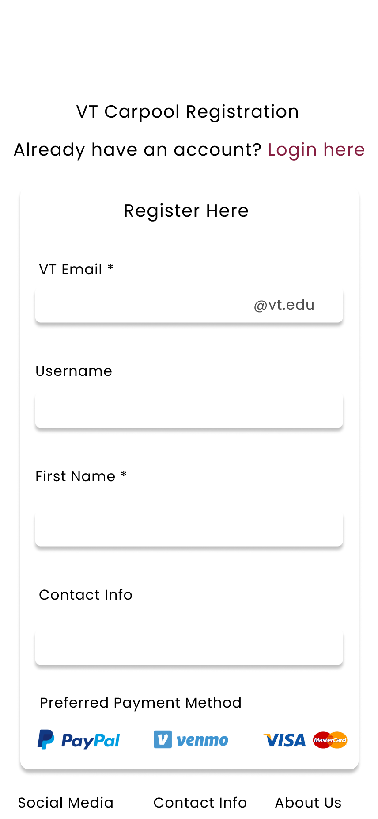

**Algorithm for Login & Registration:**

GetStarted() {

if(UserSelectedRegister) {

Register(getEmail, getUsername);

} else {

Login(getUsername);

}

}

Login(Username) {

GetPassword();

//Using a hashmap<String, String>

ValidateUsername(); //map.containsKey(username)

CheckCorrectPasswordForUser(); //map.get(username)

}

Register(Email, Username) {

If (hashmap already has username as a key) {

promptLogin();

Else {

GetPassword();

hashmap.add(username, password);

}

**Create/edit/delete profile & logout**

**UI Design for Create**/Edit/Delete **profile & Logout: (**Primary Actor: VT Student/Staff member)

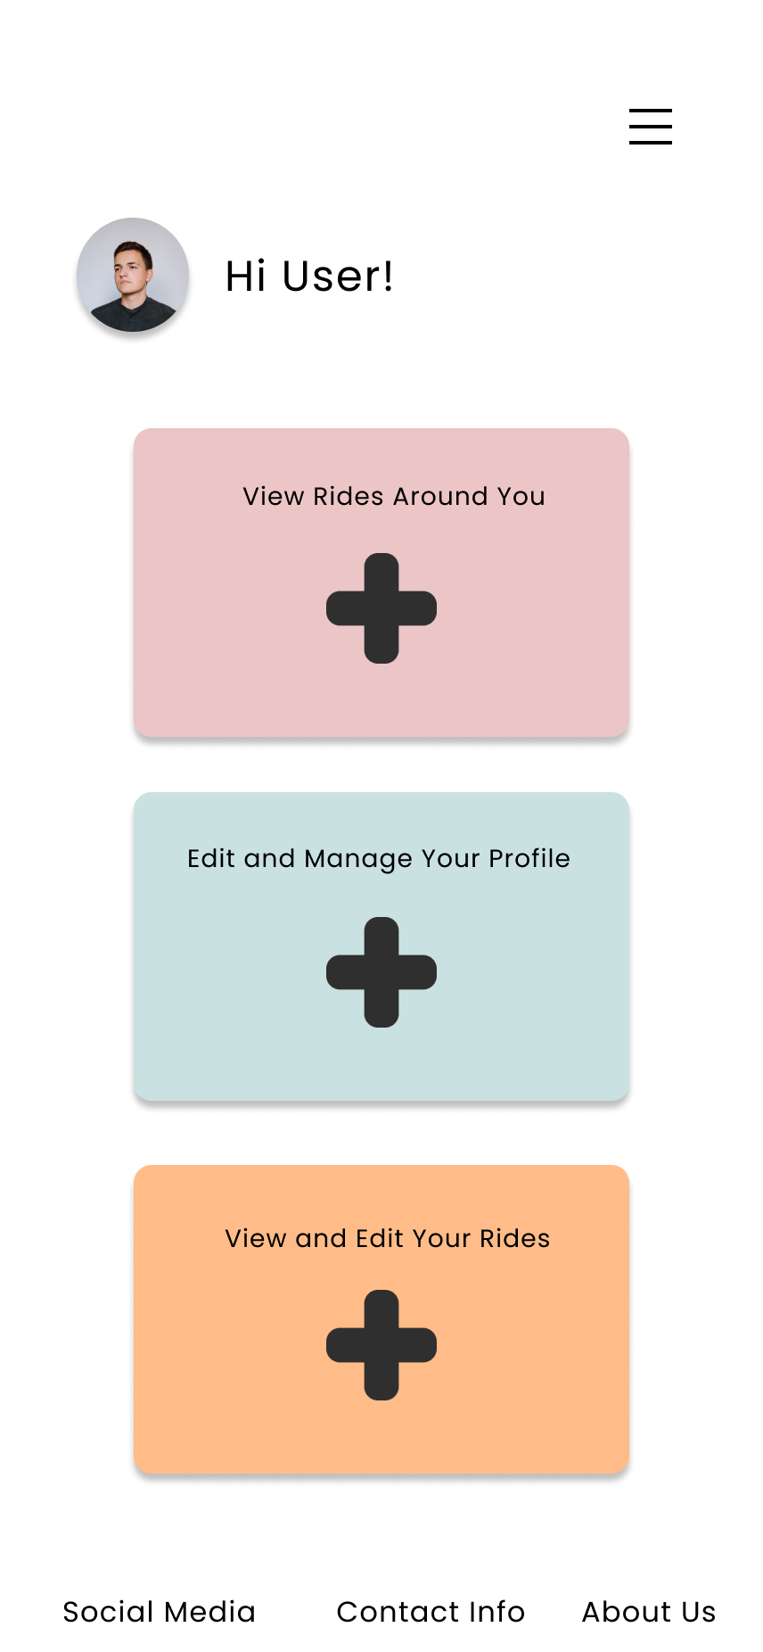

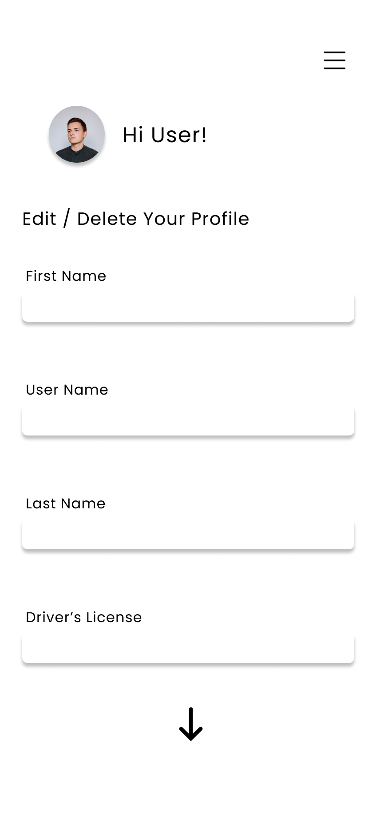

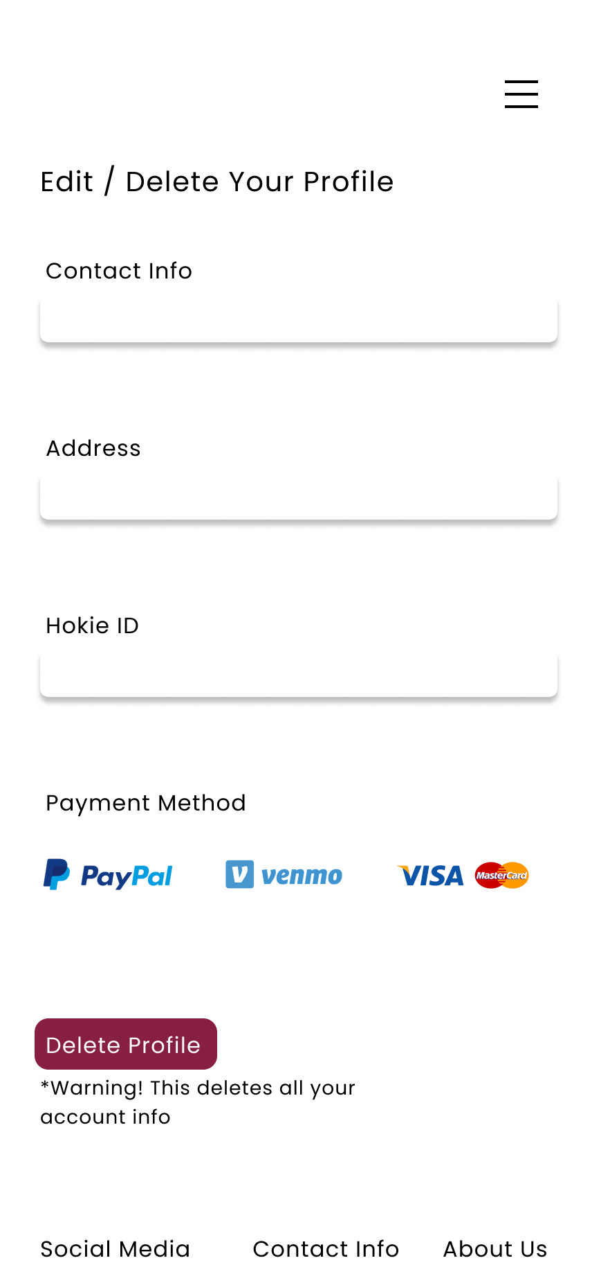



Algorithm for **Create/edit/delete profile & logout:**

ManageAccount(Username) {

PromptUserAction();

If (action == create) {

Create(Username);

} Else if (action == edit) {

If (editUsername and editPassword) {

Edit(true, true);

} else if (editUsername) {

Edit(true, false);

} else {

Edit(false, true);

}

} else {

Delete(username);

}

}

Void Create(Username) {

If (hashmap already has username as a key) {

promptLogin();

Else {

GetPassword();

hashmap.add(username, password);

}

}

Void Edit(Boolean editUsername, Boolean editPassword) {

If (editUsername) {

getNewUsername();

Password = hashmap.get(oldUsername);

hashmap.remove(oldUsername);

hashmap.add(newUsername, password);

}

If (editPassword) {

getNewPassword();

hashmap.remove(username);

hashmap.add(username, newPassword);

}

}

Boolean Delete(Username) {

If (hashmap.remove(username)) {

Return true;

}

Return false;

}

**Ability to Post/Edit/Delete a Trip Listing to the Community:**

UI Design **for Ability to Post/Edit/Delete a Trip Listing to the community: (**Primary Actor: VT Student/Staff member)

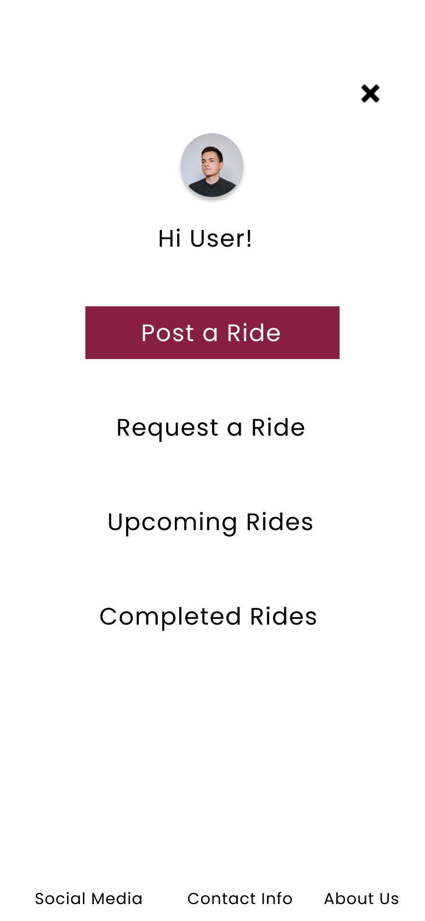

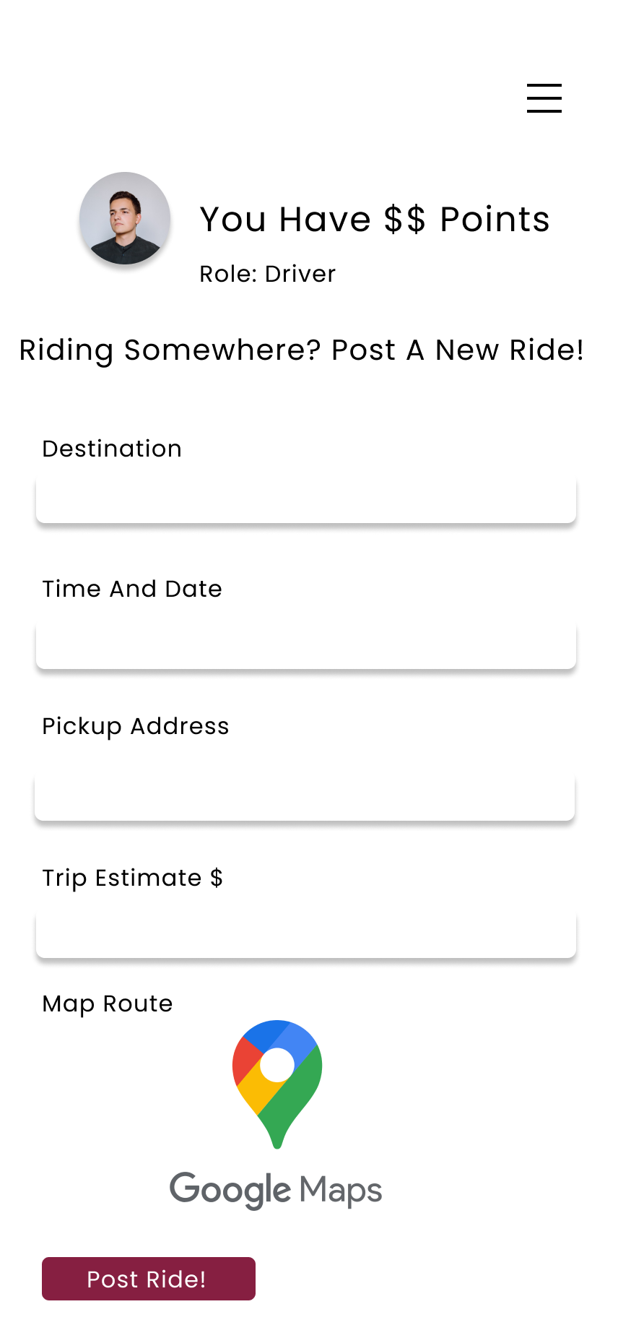

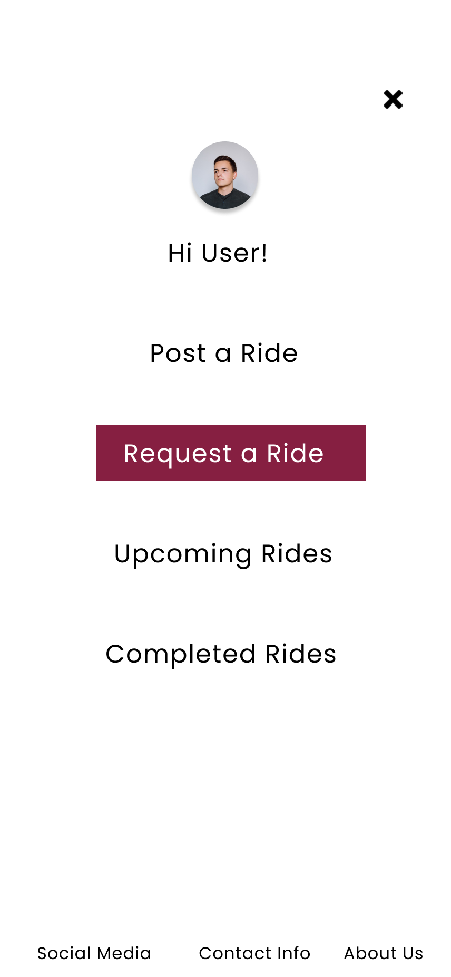

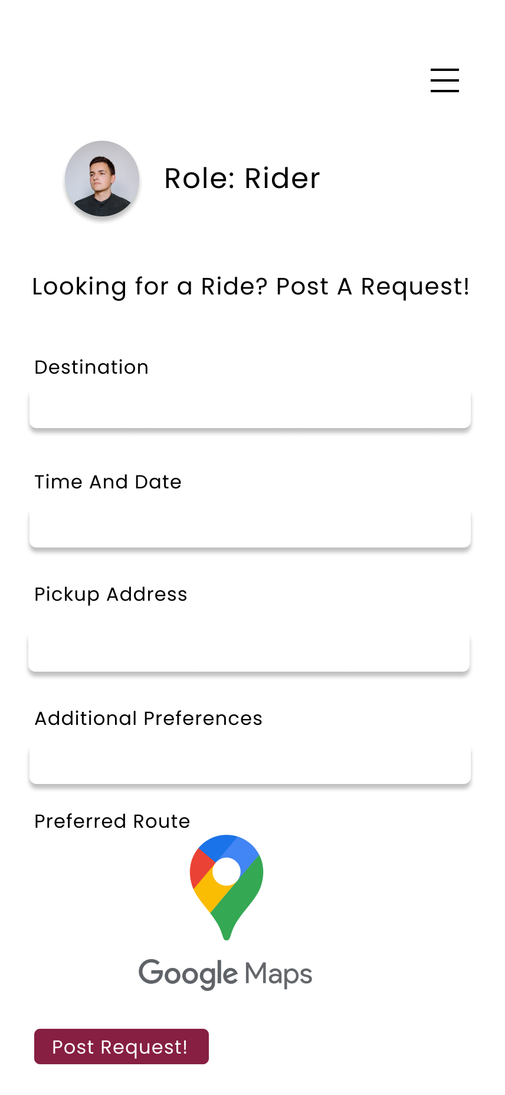

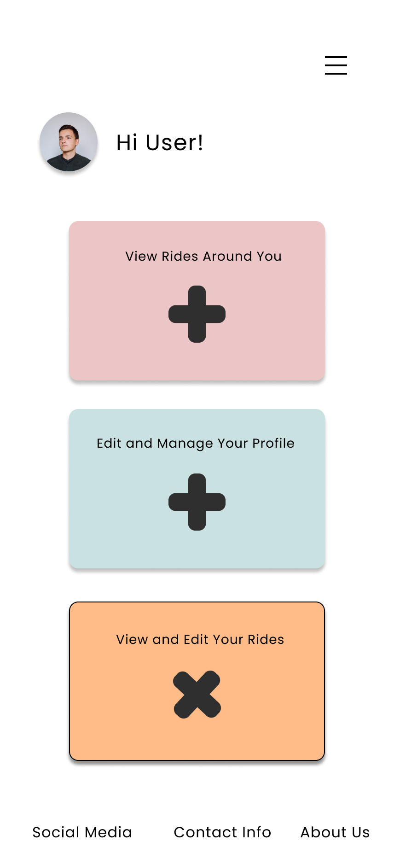

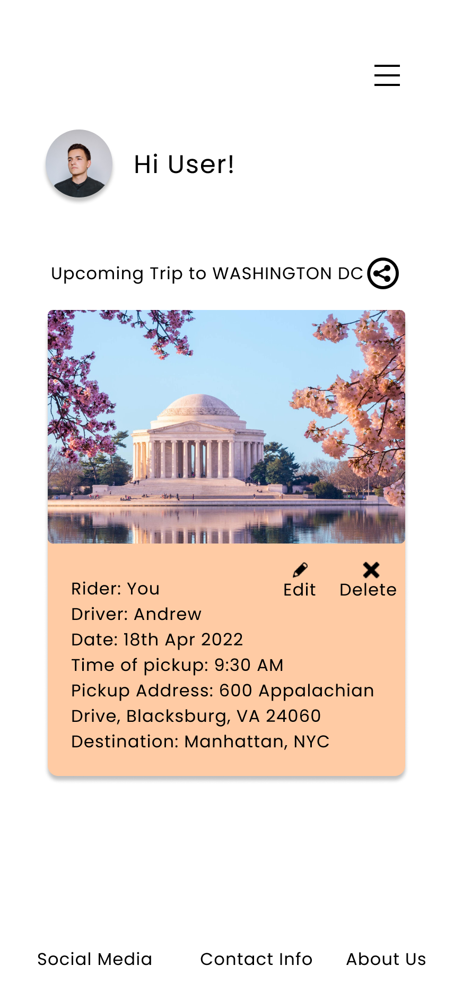

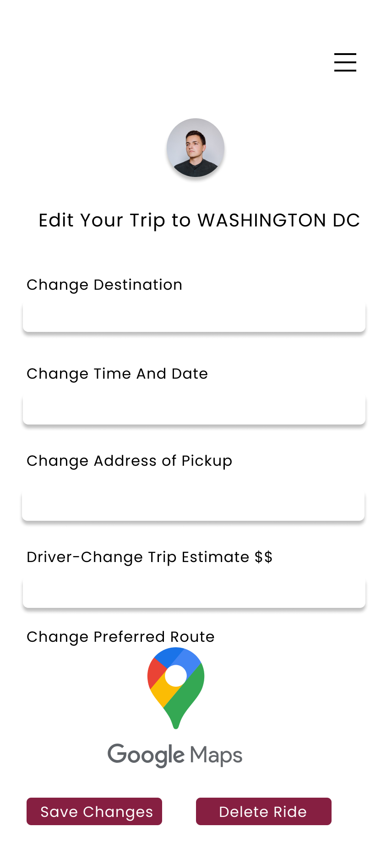

Algorithm **for Ability to Post/Edit/Delete a Trip Listing:**

Public class Trip (

Private String pickupLocation;

Private String destination;

Private Date timeOfPickup;

Trip () {};

Trip (PickupLocation, Destination, TimeOfPickup) {};

Void setPickup(Location);

String getPickup();

Void setDestination(Location);

String getDestination();

Void setTimeOfPickup(Date);

Date getPickup();

)

ManageRequests(Username) {

//uses queue of Trips

PromptUserAction();

If (action == create) {

Create(Trip);

} Else if (action == edit) {

If (editPickup and editDestination) {

Edit(Trip, true, true, false);

} else if (editPickup) {

Edit(Trip, true, false, false);

} else {

Edit(Trip, false, true, false);

}

If (editPickupTime) {

Edit(Trip, false, false, true);

}

} else {

Delete(Trip);

}

}

Void Create(Trip) {

//Queue<Trip> trips;

trips.add(Trip);

}

Void Edit(Trip trip, Boolean editPickupLocation, Boolean editDestination, Boolean editPickupTime) {

If (editPickupLocation) {

getNewPickupLocation();

trip.setPickupLocation(newLocation);

}

If (editDestination) {

getNewDestination();

trip.setDestination(newLocation);

}

If (editPickupTime) {

getNewPickupTime();

trip.setPickupTime(newTime);

}

Return trip;

}

Boolean Delete(Trip trip) {

If (queue.remove(trip)) {

Return true;

}

Return false;

}

**Sorting Listings**

UI Design for Sorting Listings**: (**Primary Actor: Registered Driver & Rider)

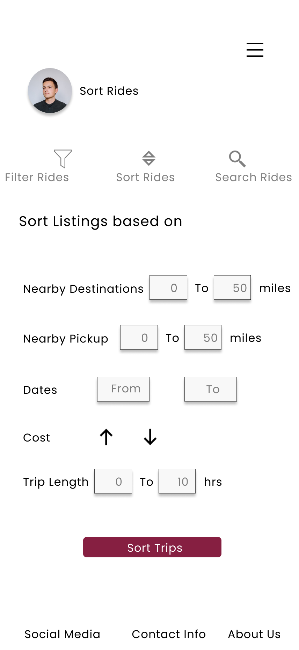

Algorithm for Sorting Listings:

Public class Trip (

Private String pickupLocation;

Private String destination;

Private Date timeOfPickup;

Trip () {};

Trip (PickupLocation, Destination, TimeOfPickup) {};

Void setPickup(Location);

String getPickup();

Void setDestination(Location);

String getDestination();

Void setTimeOfPickup(Date);

Date getPickup();

)

Trip[] SortListings(Trip[] page, Location pickup=Null,Location dest=Null, Date date=Null, Time time=Null){

//Use N number of merge sorts since they are stable to sort listings

If(dest) page = mergesort(page, dest)

If(pickup) page = mergesort(page, pickup)

If(date) page = mergesort(page, date)

If(time) page = mergesort(page, time)

Return page

}

**Transactions**

UI Design for Transactions: (**Primary Actors: Registered** Rider & Driver)

Algorithm for Transactions:

Class User {

String[] notifications;

String Name;

String userId;

String email;

User[] friends;

}

//Transactions listing is a social feature similar to payment like Venmo no actual amounts are shown

String[] getTransactions(User user) {

List ledger = new list()

for(User:friend in user.friends){

For (transc in friend.transactions) {

ledger.append(transc)

}

}

Return ledger

}

Forgot Password

UI Design for Forgot Password Functionality: (Primary Actor: Registered Driver & Rider)



Algorithm for Forgot Password: Shown in email configuration

**Email Confirmation**

UI Design for Email Confirmation: (**Primary Actor: Register**ed Drivers & Riders): Shown in Forgot Password



Algorithm for Forgot Password & Email Confirmation:

void resetPassword(String email, String username) {

if (validEmail(email)) {

if (confirmUsername(email, username)) {

sendEmailConfirmation(email, username, “Success”);

}

}

else {

sendEmailConfirmation(email, username, “Failure”);

}

}

Boolean sendEmailConfirmation(String email, String username, String flag) {

if (!validEmail(email) || !confirmUsername(email, username)) {  
 return false;

}

String message = “”;

switch (flag) {

case “Success”:

message = “Here is a link to reset your password.”

case “Failure”:

message = “There does not exist an account under this email.”

}

sendEmail(email, username, message);

return true;

}

**Trip Duration Estimate**

UI Design **for Trip Duration Functionality: (**Primary Actor: Rider)

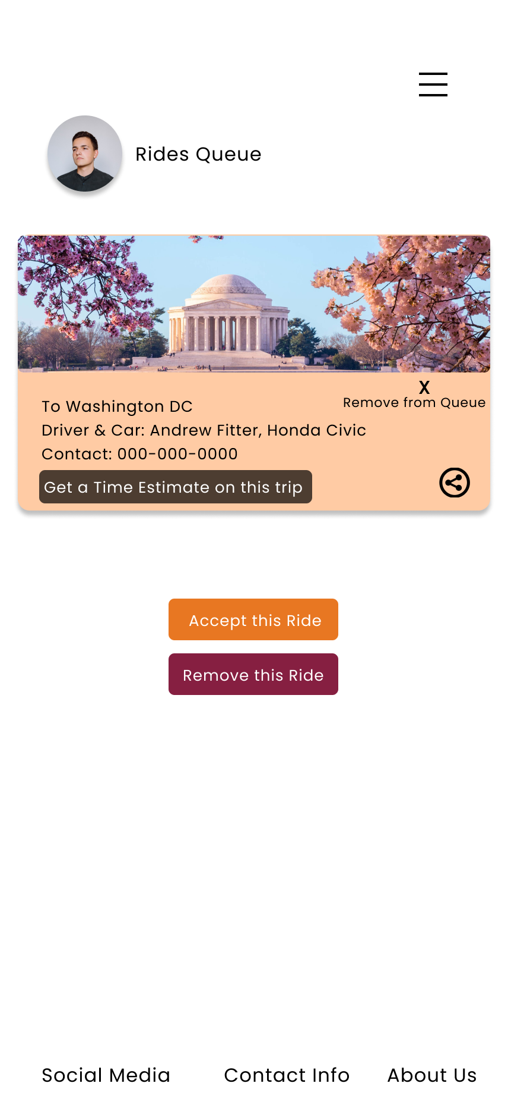

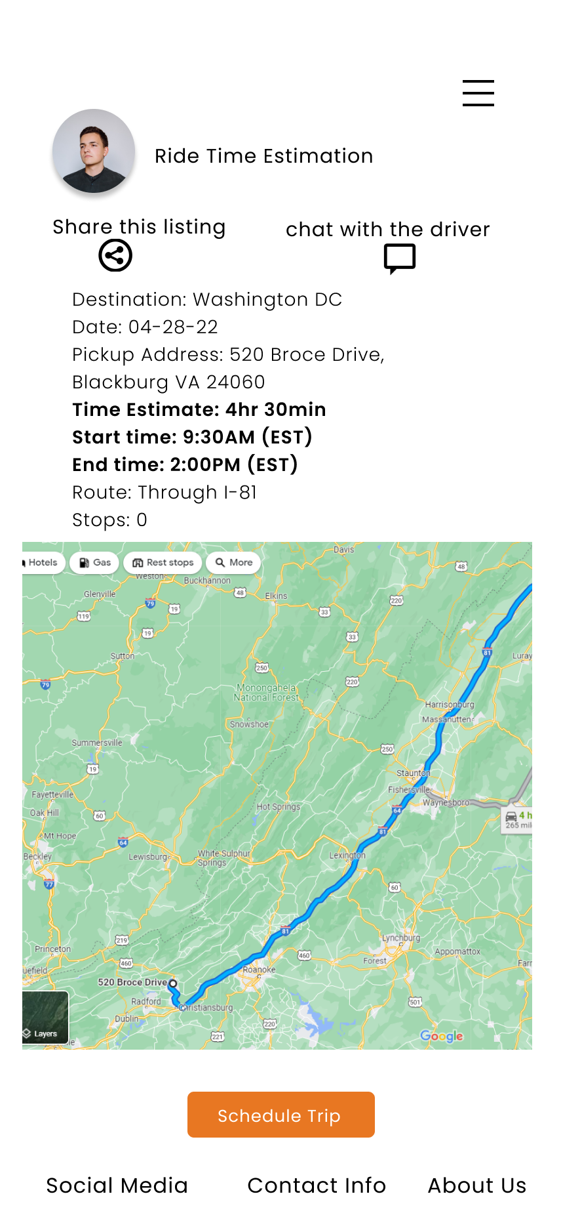

Algorithm for Trip Duration Estimate Functionality:

Boolean HandleRequest(Trip trip) {

If (driverAccepts(trip)) {

sendTripDuration(trip, Rider, Driver);

Return true;

}

Return false;

}

Void sendTripDuration(Trip trip, User rider, User driver) {

//uses LRU cache for recent trips to same destination

//uses gps tracking from pickup to destination if not in cache

For (each trip is list from LRU) {

Duration = Sum duration / number of trips;

sendDuration(rider, Duration);

sendDuration(driver, Duration);

}

}

Void sendDuration(User user, String Duration) {

getUserScreen(user);

displayMessage(Duration);

}

**Route Planning**

UI Design **for Route Planning Functionality: (Primary Actor: Driver)**

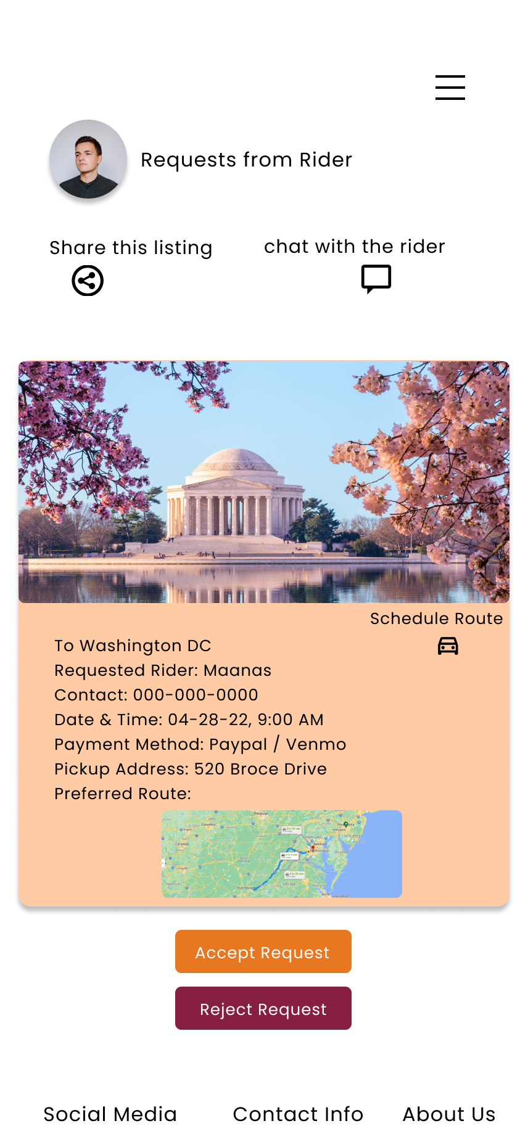

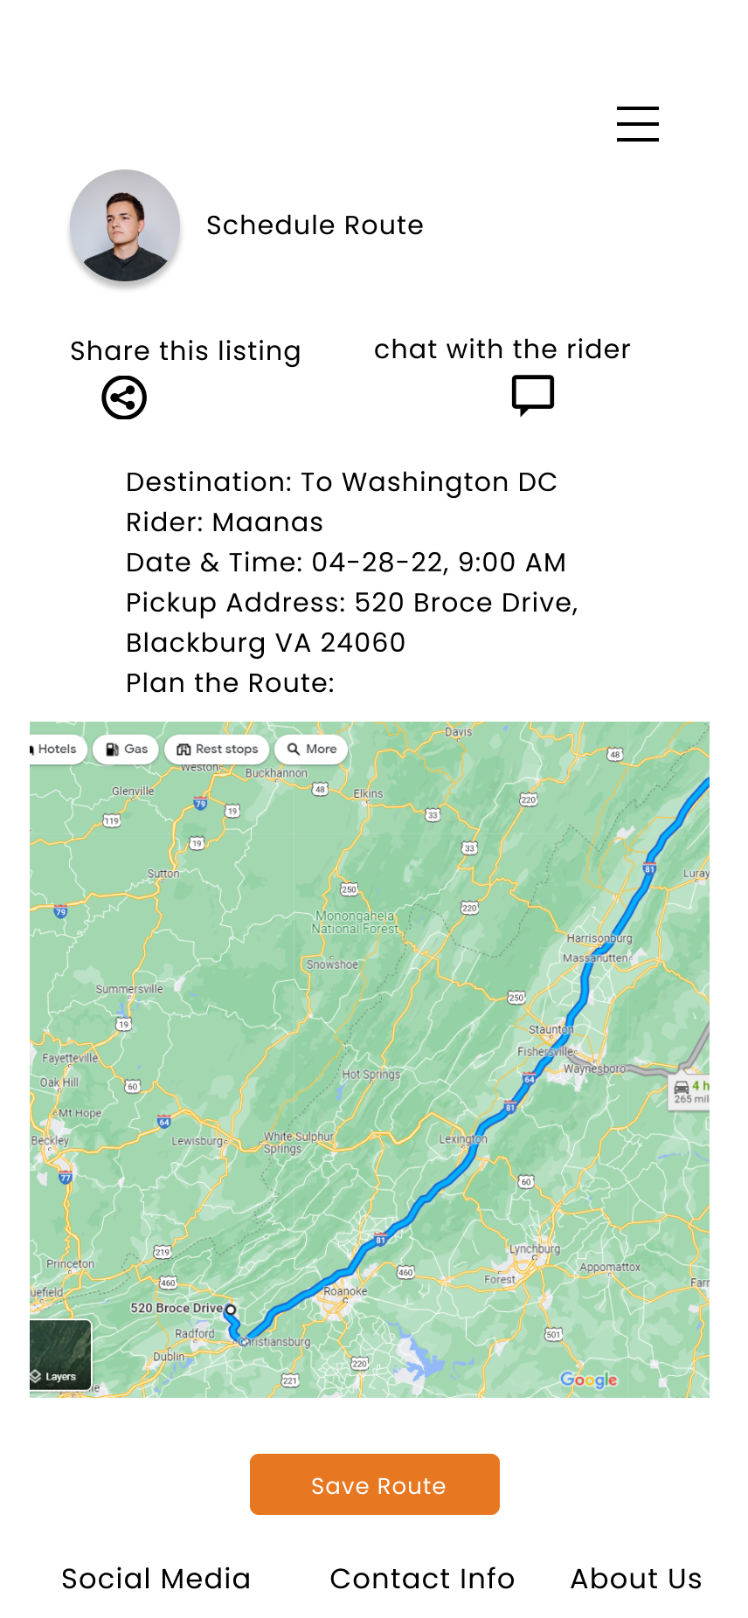

Algorithm For Route Planning:

Public class Trip (

Private String pickupLocation;

Private String destination;

Private Date timeOfPickup;

Trip () {};

Trip (PickupLocation, Destination, TimeOfPickup) {};

Void setPickup(Location);

String getPickup();

Void setDestination(Location);

String getDestination();

Void setTimeOfPickup(Date);

Date getPickup();

)

Trip getShortestRoute(Trip trip ) {

//uses LRU cache for recent trips to same destination

//uses gps tracking from pickup to destination if not in cache

For (each trip is list from LRU) {

//quicksort each trip based on shortest length

Return shortestTrip;

}

}

Trip **Scheduling**

UI design **for** Trip **Scheduling Functionality: (Primary Actor:Rider)**

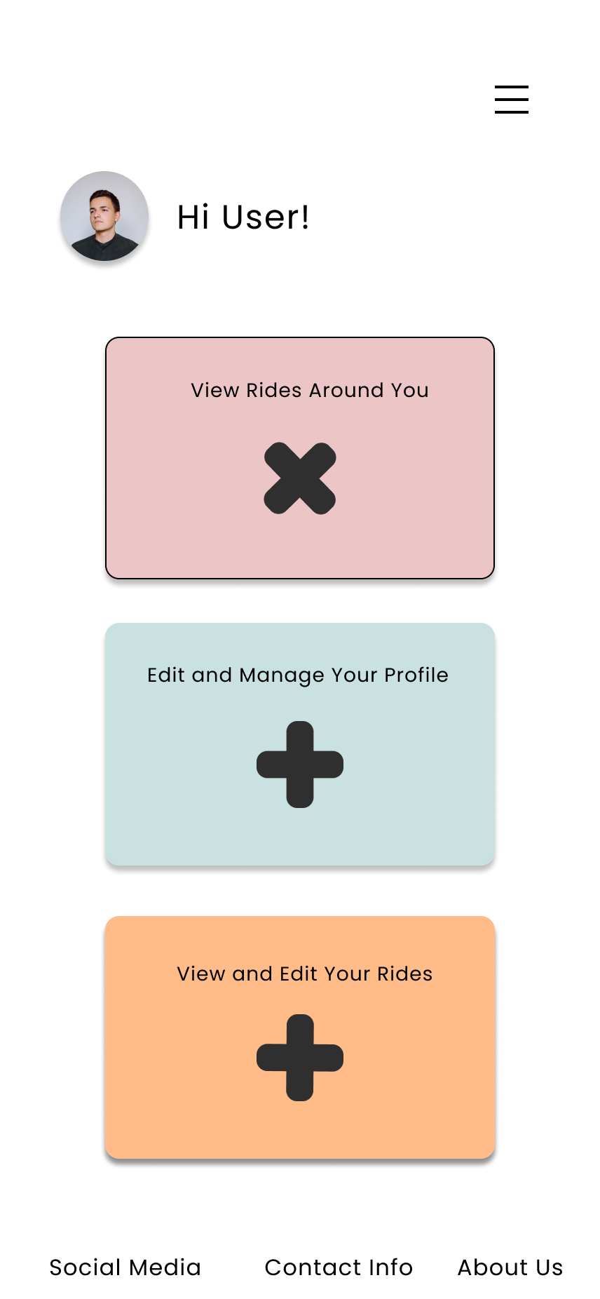

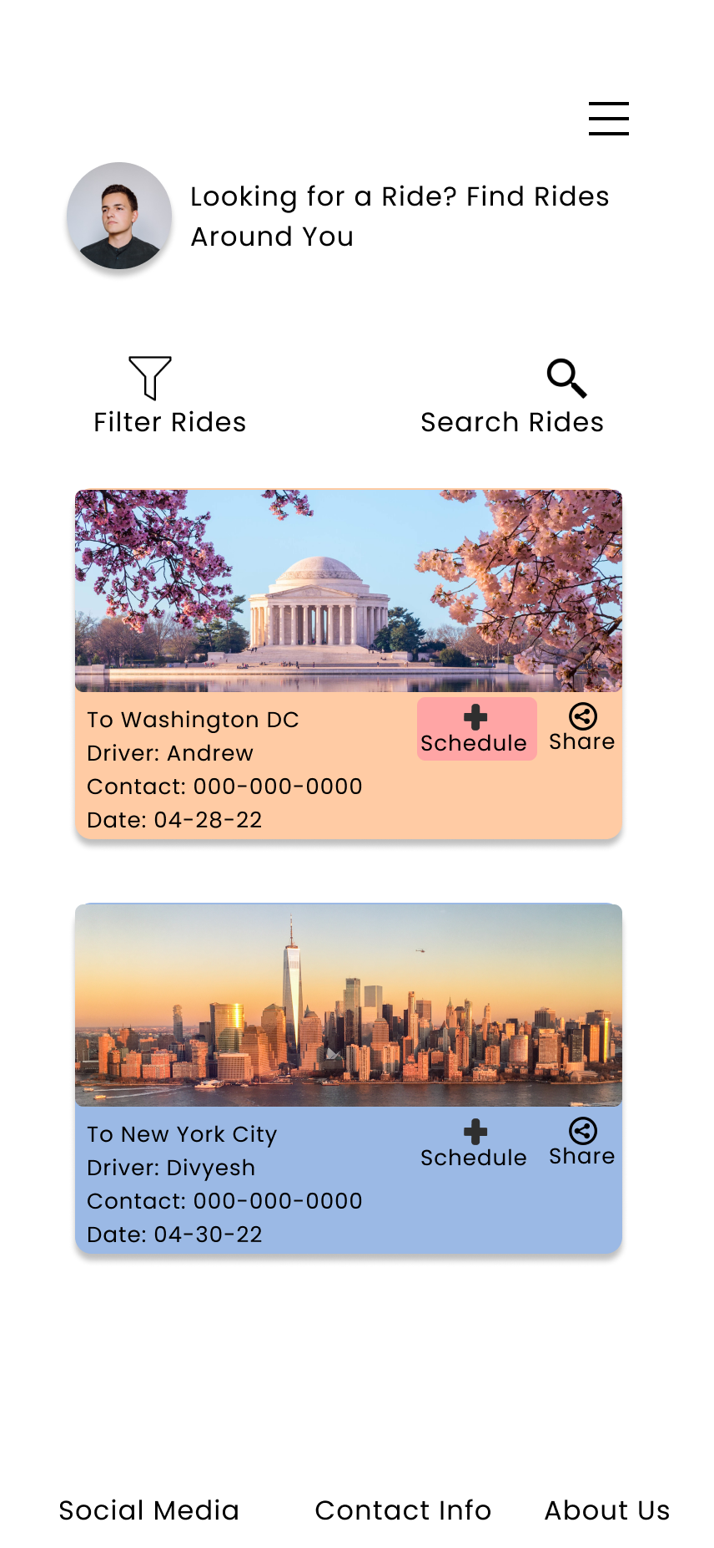

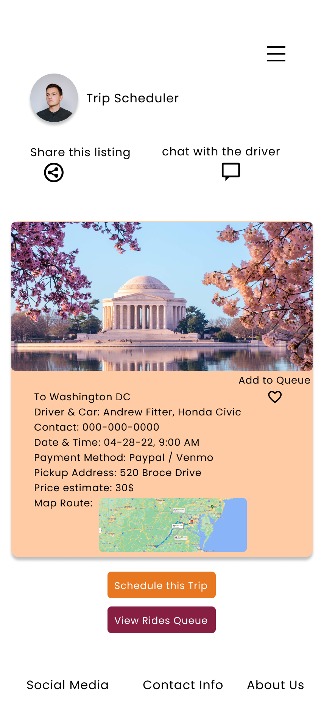



Algorithm for Trip Scheduling Functionality:

Public class Trip (

Private String pickupLocation;

Private String destination;

Private Date timeOfPickup;

Trip () {};

Trip (PickupLocation, Destination, TimeOfPickup) {};

Void setPickup(Location);

String getPickup();

Void setDestination(Location);

String getDestination();

Void setTimeOfPickup(Date);

Date getPickup();

)

ManageRequests(Username) {

//uses queue of Trips

PromptUserAction();

If (action == create) {

Create(Trip);

} Else if (action == edit) {

If (editPickup and editDestination) {

Edit(Trip, true, true, false);

} else if (editPickup) {

Edit(Trip, true, false, false);

} else {

Edit(Trip, false, true, false);

}

If (editPickupTime) {

Edit(Trip, false, false, true);

RemindDriver(pickupTime, Driver);

}

} else {

Delete(Trip);

}

}

Void RemindDriver(Date pickupTime, User Driver) {

getDriverScreen(Driver);

alertDriver(“Trip scheduled for ” + pickupTime);

}

Void Create(Trip) {

//Queue<Trip> trips;

trips.add(Trip);

}

Void Edit(Trip trip, Boolean editPickupLocation, Boolean editDestination, Boolean editPickupTime) {

If (editPickupLocation) {

getNewPickupLocation();

trip.setPickupLocation(newLocation);

}

If (editDestination) {

getNewDestination();

trip.setDestination(newLocation);

}

If (editPickupTime) {

getNewPickupTime();

trip.setPickupTime(newTime);

}

Return trip;

}

Boolean Delete(Trip trip) {

If (queue.remove(trip)) {

Return true;

}

Return false;

}

Trip **Group Messaging**

UI Design for Trip Group Messaging**: (Primary Act**or: Register Driver & Rider)



Algorithm For Trip Group Messaging**:**

Public class Trip (

Private String pickupLocation;

Private String destination;

Private Date timeOfPickup;

Trip () {};

Trip (PickupLocation, Destination, TimeOfPickup) {};

Void setPickup(Location);

String getPickup();

Void setDestination(Location);

String getDestination();

Void setTimeOfPickup(Date);

Date getPickup();

Users riders;

)

Class User {

String[] notifications;

String Name;

String userId;

String email;

User[] friends;

String number;

}

SendMessage(String message, Trip ride) {

For( rider in ride.riders) {

send(message, rider,number);

}

}

## **Search/Filter Listings**

UI Design for Search and Filter Listings**: (Primar**y Actor: Registered Rider)

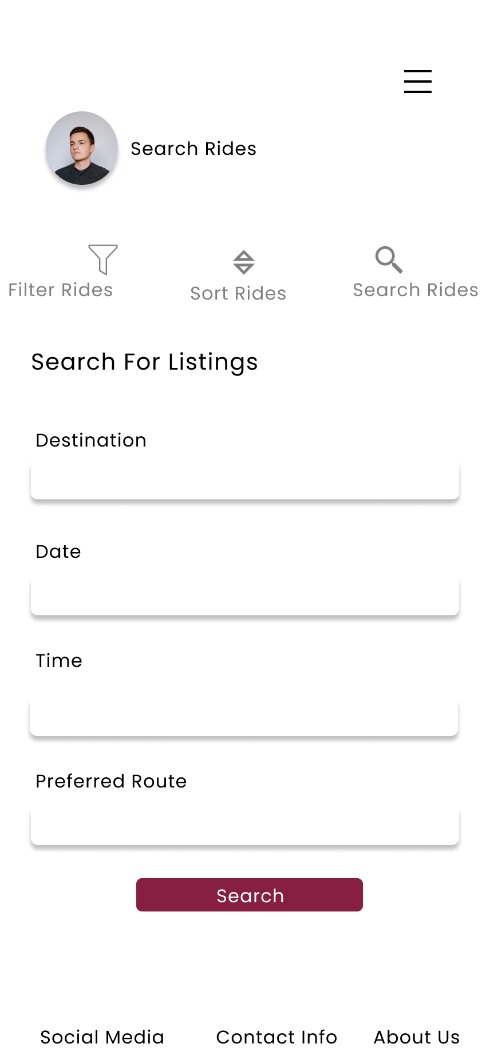

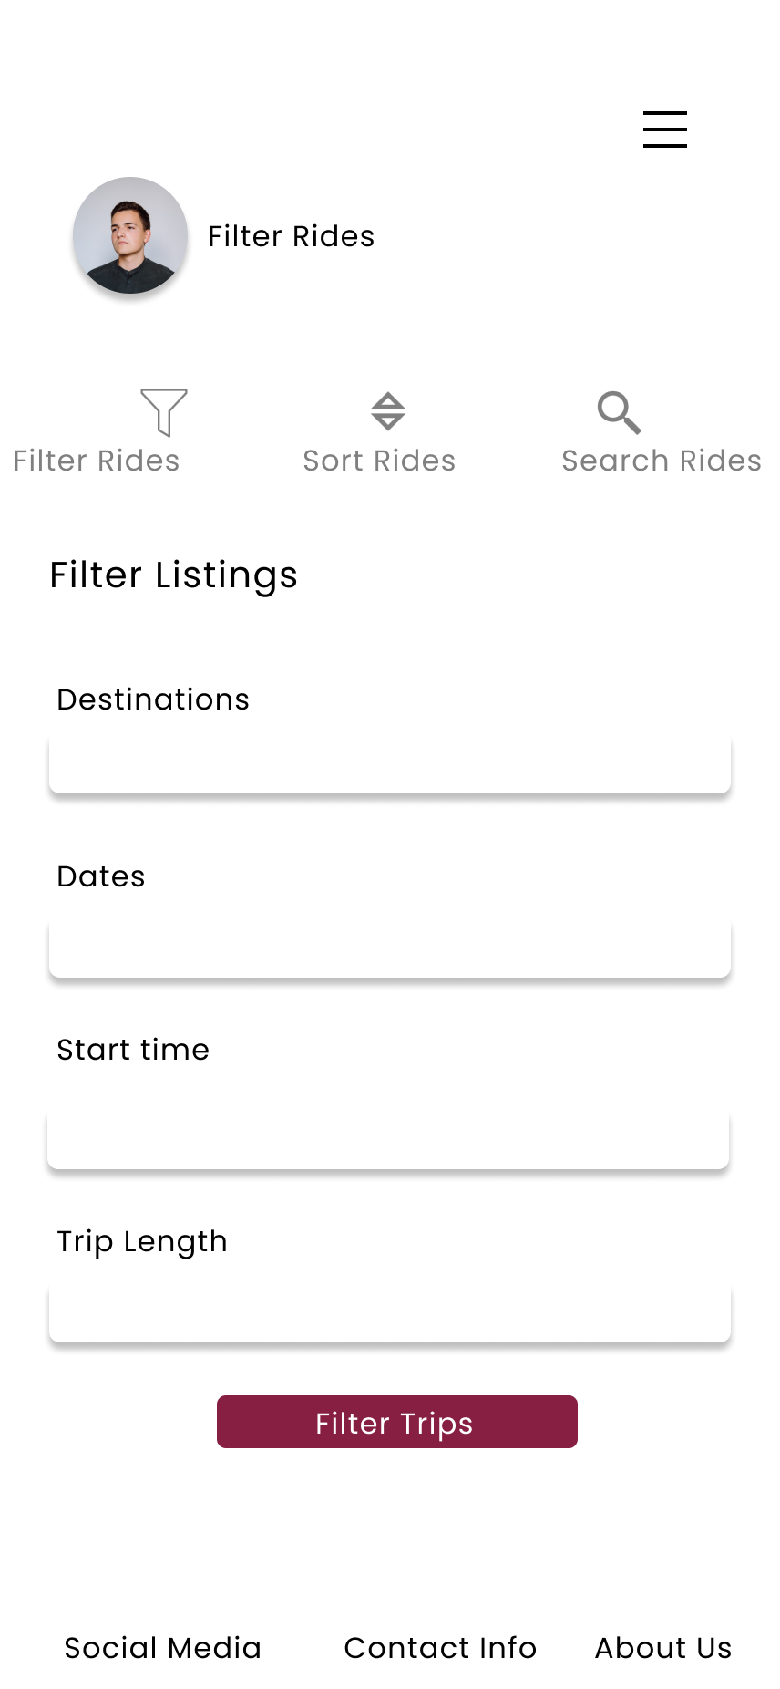

Algorithm for Search/Filter Listings:

Public class Trip (

Private String pickupLocation;

Private String destination;

Private Date timeOfPickup;

Trip () {};

Trip (PickupLocation, Destination, TimeOfPickup) {};

Void setPickup(Location);

String getPickup();

Void setDestination(Location);

String getDestination();

Void setTimeOfPickup(Date);

Date getPickup();

)

Trip[] SearchListings(Trip[] page, Location pickup,Location dest, Date date, Time time){

//implement a traversal for fastest way to find n matches and return them

Trip[] res;

for (elem in page){

if(elem.pickup = pickup and elem.dest == dest and elem.date == date and elem.time == time){

res.append(elem)

}

}

}

//Optional Params

Trip[] FilterListings(Trip[] page, Location pickup=Null,Location dest=Null, Date date=Null, Time time=Null){

//Use N number of merge sorts since they are stable to sort listings

If(dest) page = filter(page, dest)

If(pickup) page = filter(page, pickup)

If(date) page = filter(page, date)

If(time) page = filter(page, time)

Return page

}

## **Share Ride**

UI Design Diagram for Share Ride**: (P**rimary Actor: Registered Rider & Driver)



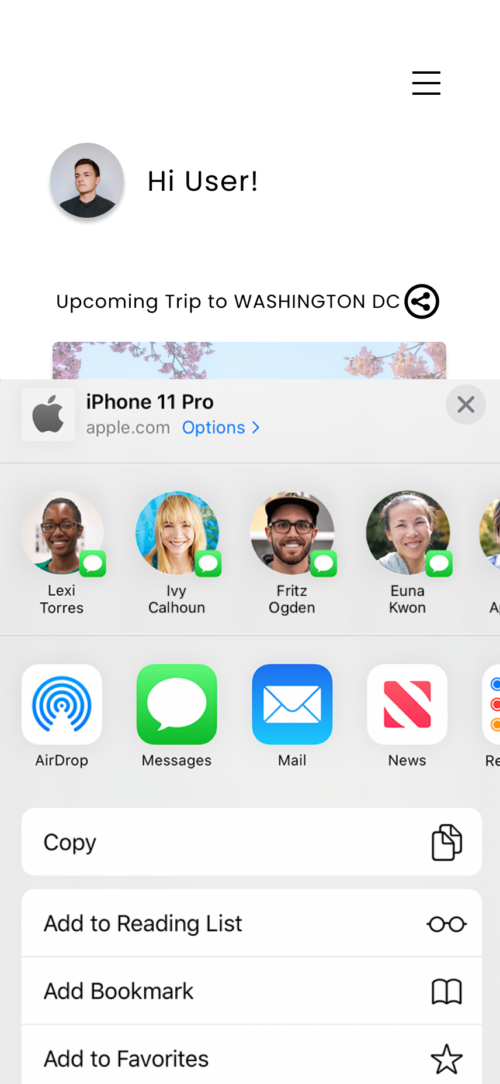

Algorithm for Share Ride:

Public class Trip (

Private String pickupLocation;

Private String destination;

Private Date timeOfPickup;

Trip () {};

Trip (PickupLocation, Destination, TimeOfPickup) {};

Void setPickup(Location);

String getPickup();

Void setDestination(Location);

String getDestination();

Void setTimeOfPickup(Date);

Date getPickup();

String url;

)

String ShareRide(Trip trip) {

//Copy trip url to clipboard and return

device.copytoclipboard(trip.url)

Return trip.url

}

## **Listing Notifications**

UI Design for Listing Notifications**:(**Primary Actors: Registered Riders & Drivers)

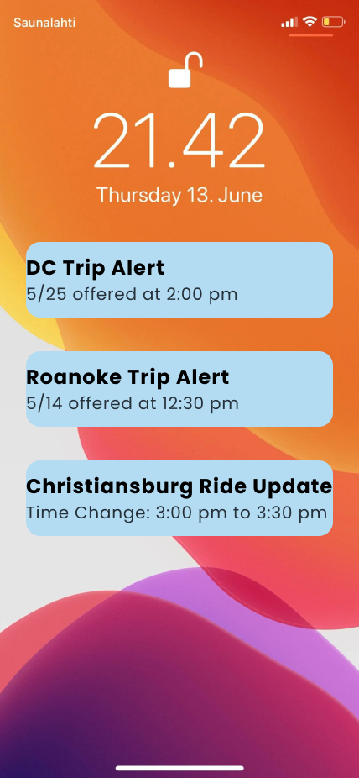

Algorithm for Listing Notifications:

Class User {

String[] notifications;

String Name;

String userId;

String email;

Function RemoveNotif(String Notif)

}

Void CheckforNotifs(User user) {

String[] notifs = user.notifs

//Assuming Notif Body and Text is separated with a ‘:’ delmiter

for (notif in notifs) {

device.pushtouser(notif.split(0, ‘:’), notif.split(1, ‘:’) )

user.removeNotif(notif); // Remove it from unpushed notifs array

}

}

**Maps routing**

UI Design for **Maps Routing Functionality:** (Primary Actor: Registered Driving)

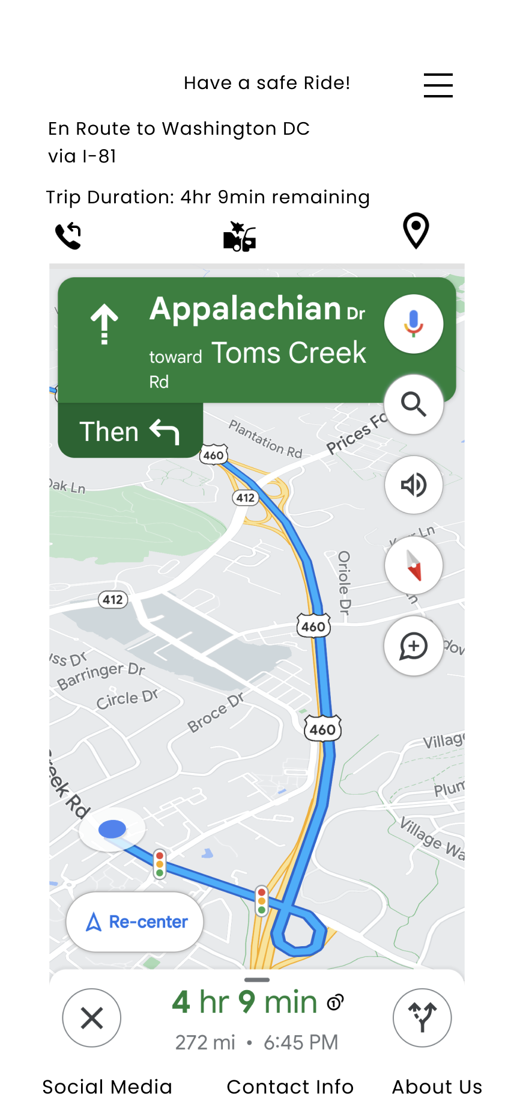

Algorithm **for Map Routing:**

Public class RideQueue {

Queue<Direction> route;

List<Address> destinations;

double tripDuration;

Public RideQueue(Address destination) {

route = new Queue<Direction>();

Destinations = new List<Address>();

tripDuration = 0;

}

public boolean addRide(Address destination) {

Address begin = route.getLast();

Queue<Direction> to_append = MapServicesAPI.retrieveQueue(begin, destination);

if (to_append == null) {

return false;

}

tripDuration += MapServicesAPI.retrieveDuration(to_append);

route.append(to_append);

destinations.add(destination);

}

public boolean deleteRide(Address destination) {

destinations.remove(destination);

// rebuilds route queue by adding each destination

route = new Queue<Direction>();

for (int i = 0; i < destinations.length(); i++) {

If (!addRide(destinations.get(i))) {

return false;

}

}

return true;

}

public void updateTripDuration() {

tripDuration = MapServicesAPI.retrieveDuration(route);

}

public double getTripDuration() {

return tripDuration;

}

public void notifyRider(String msg, User rider) {

rider.getScreen().notify(msg);

}

public void notifyDriver(String msg, User driver) {

driver.getScreen().notify(msg);

}

}